**Plan and Design of the Project:**

**Application Tracking System (ATS)**

**Workflow of an ATS:**

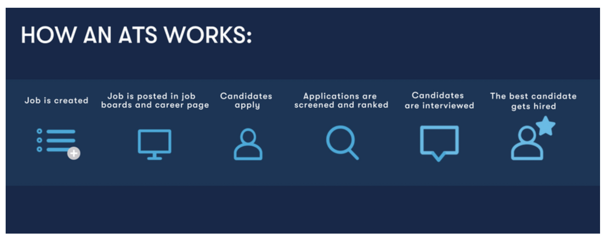

**Project Design and Plan:**

We are implementing/designing the application in python language.

* **Dashboard:** Dashboard consists of all the summary activity of other modules data (as the modules mentioned below)
* **Accounts:** In a simple way to say this module consists of Client information.
* **Contacts:** Person between candidates and Accounts.
* **Openings:** Requirements where we get from clients.
* **Candidates:** People who are searching for the jobs based on the skills.
* **Pipeline:** Submitting the candidate based on the requirement and skills. (Where all the different status of the candidate can be traced)
* **Placements:** Final stage of the candidate recorded in this module. Along with all other data and record information.